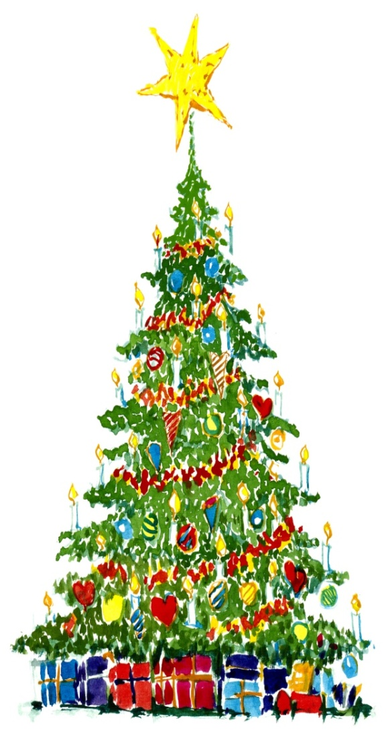
Wigston, Bell Street
Christmas lights switch on
26th November 2016
4.00pm – 7.00pm

Come down to Bell Street to watch
Christmas Magic begin, Elves with
palms of candy, swirling rides
from Billy Bates Fair.
Along with a special guest from
his North Pole workshops at 4pm.
The lights will be switched
on at 6.00pm.

- Billy Bates Fair
- Father Christmas
Plus a host of specialist and festive food stalls
Something for the whole family – see you there!

Organised by Oadby & Wigston Lions Club

